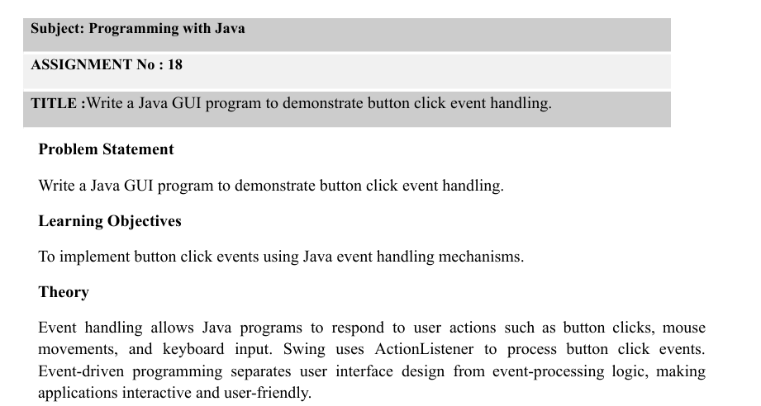
1. Theory
Event handling in Java is used to perform an action when a user interacts with a GUI component, such as clicking a button. Java provides the ActionListener interface to handle button-click events.
- JButton: Creates a clickable button.
- ActionListener: Handles events generated by clicking a button.
- actionPerformed(): Executes the code when the button is clicked.
- JFrame: Creates the main application window.
- JTextField: Accepts input from the user.
- JOptionPane: Displays messages or results in a dialog box.
Event handling makes Java GUI applications interactive and user-friendly.
2. Algorithm
- Start the program.
- Import the required Swing and AWT packages.
- Create a class that extends JFrame.
- Create the required labels, text fields, and buttons.
- Add the components to the frame.
- Implement the ActionListener interface.
- Define the actionPerformed() method to handle button clicks.
- Retrieve the values entered by the user.
- Perform the required operation, such as addition, subtraction, deposit, or withdrawal.
- Display the result using JOptionPane or a label.
- Set the frame visible.
- Stop the program.

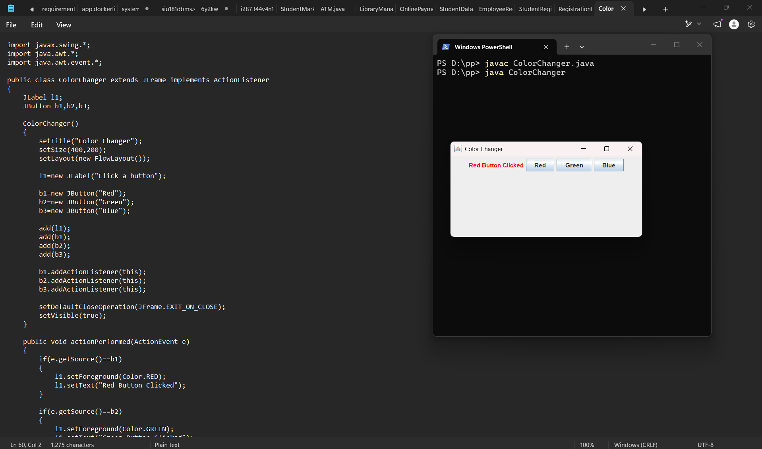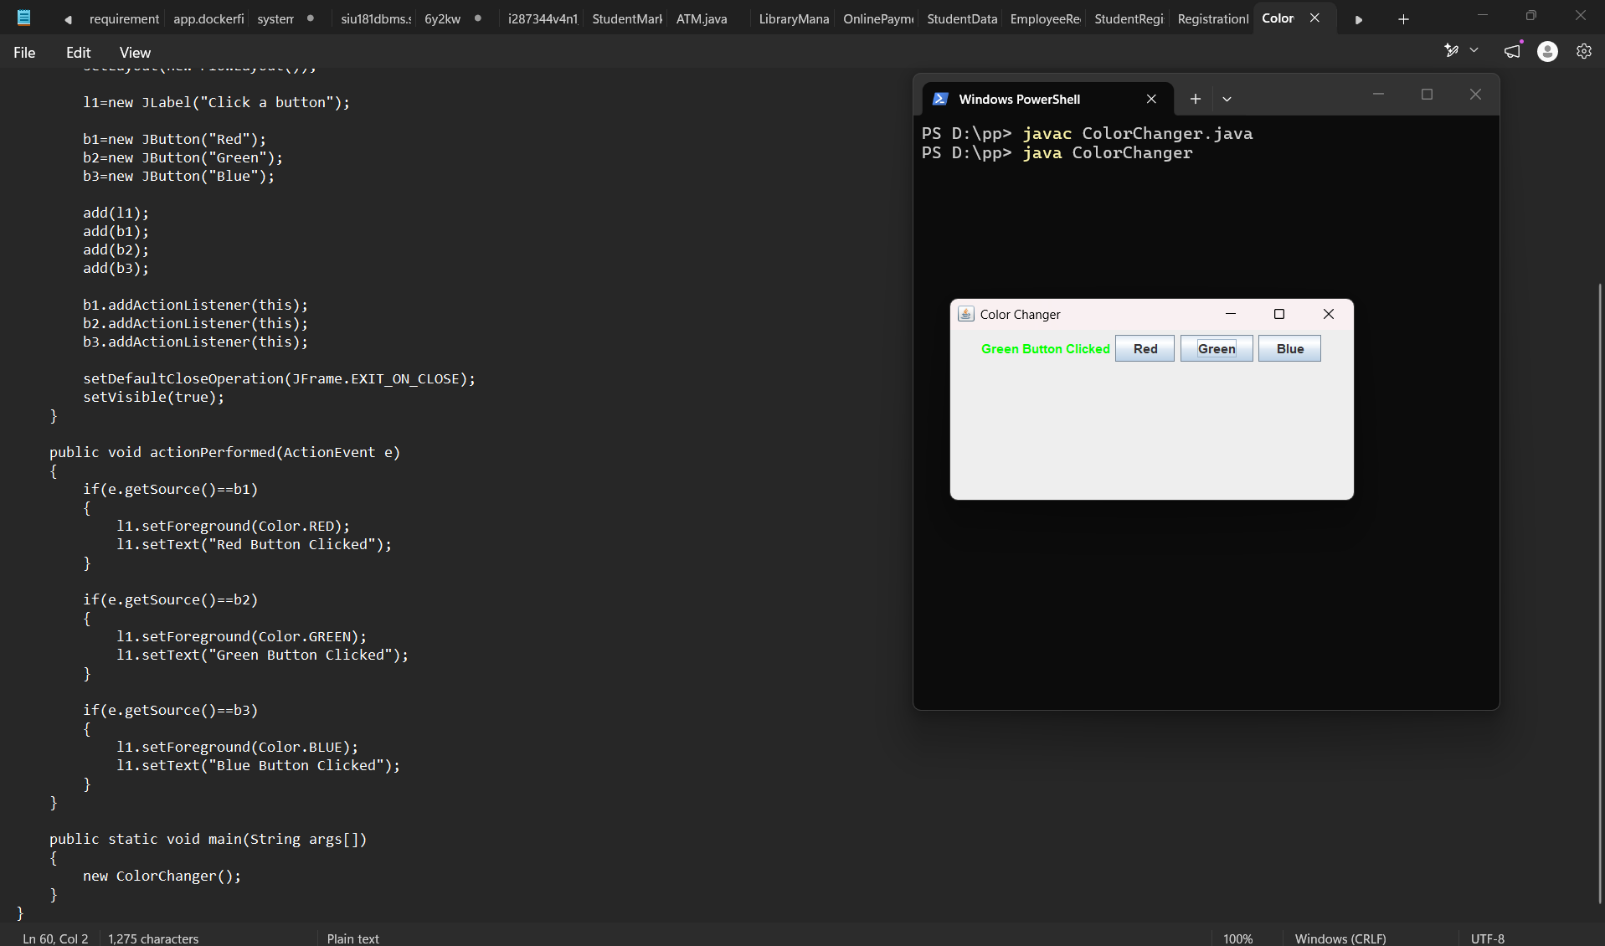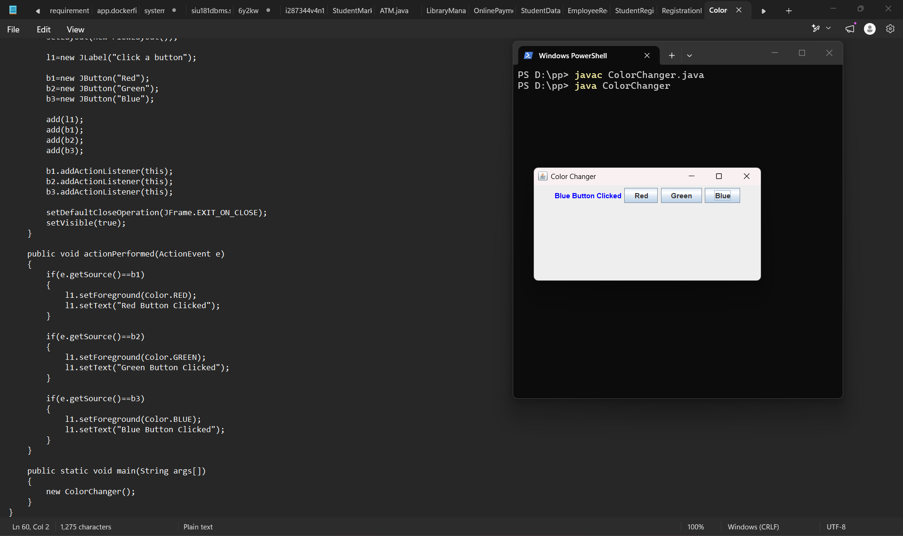
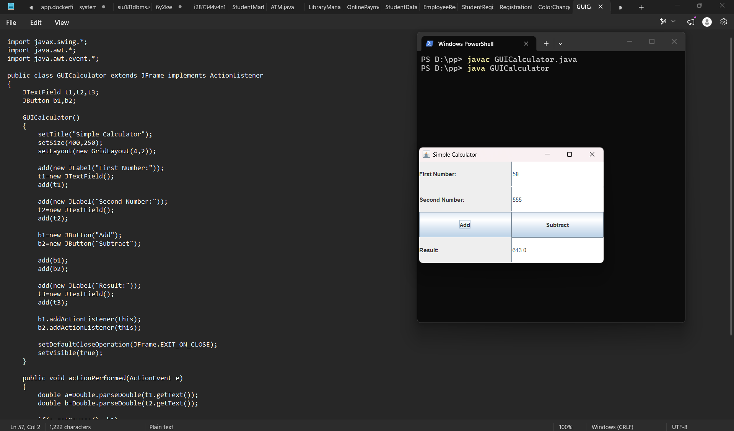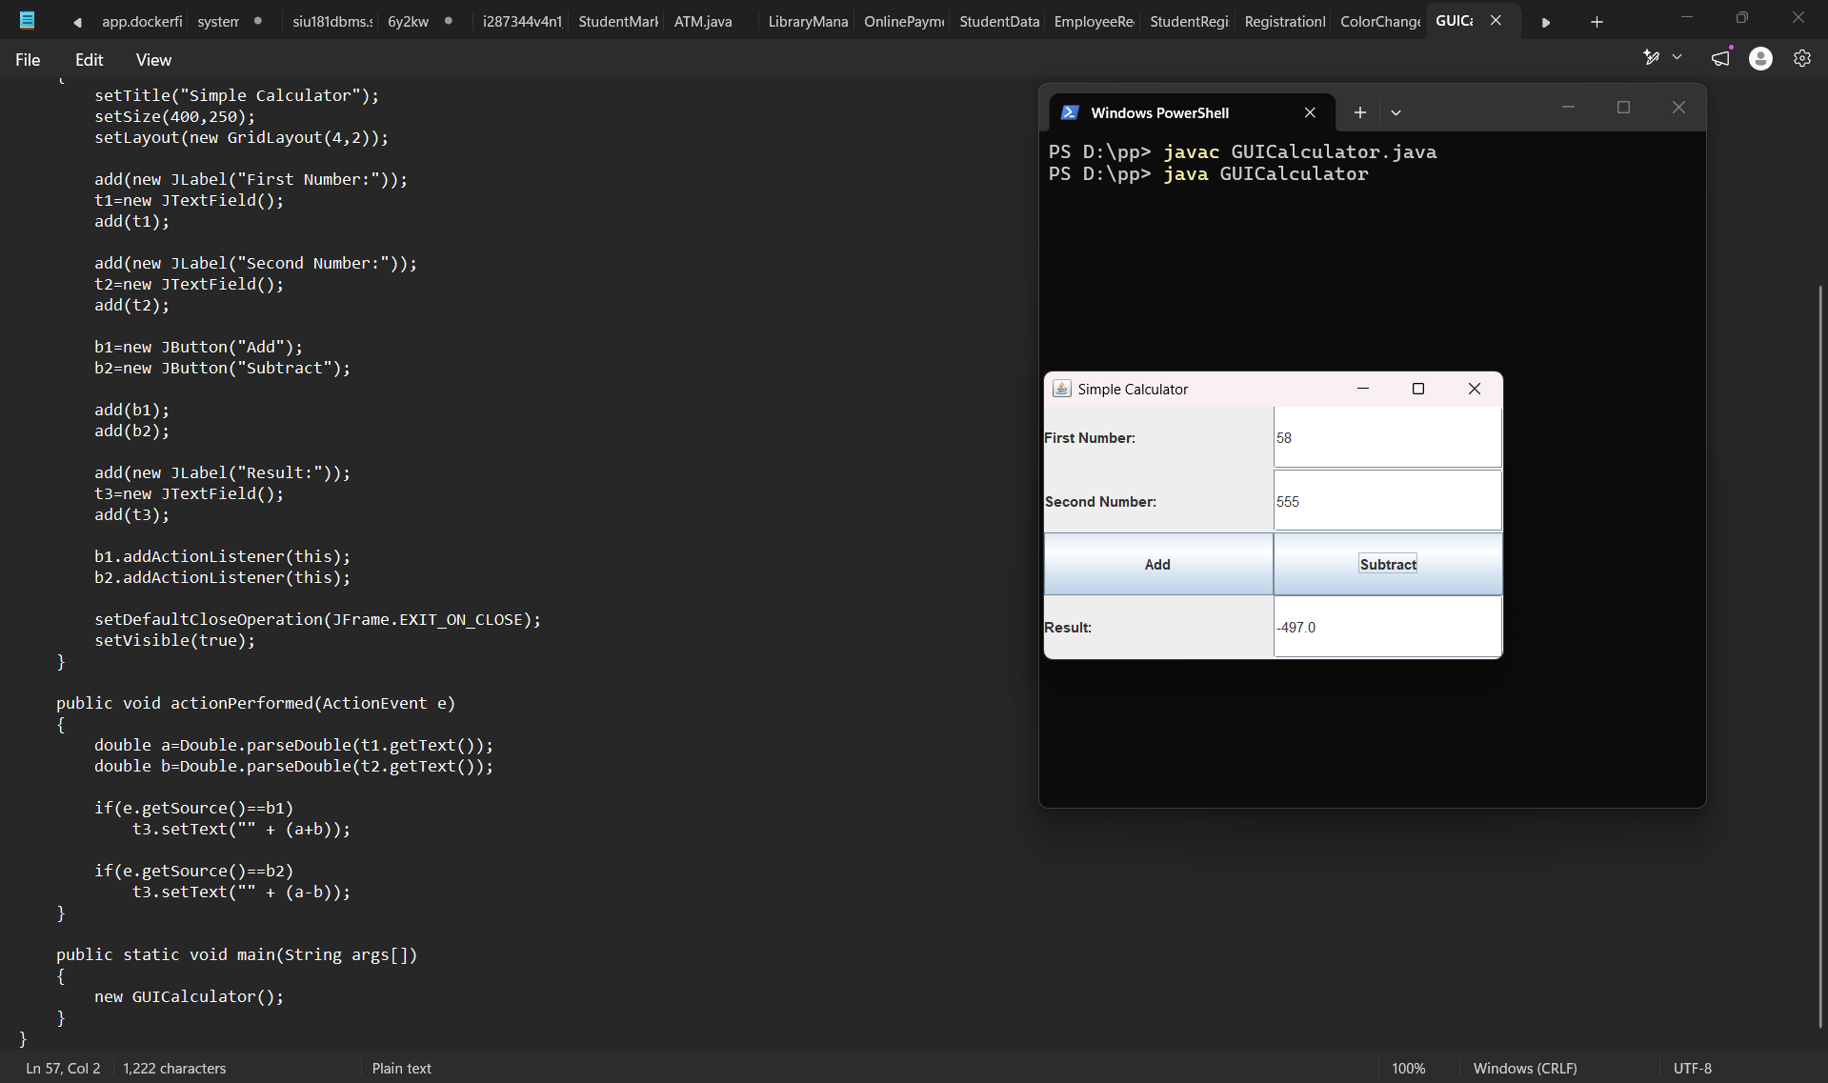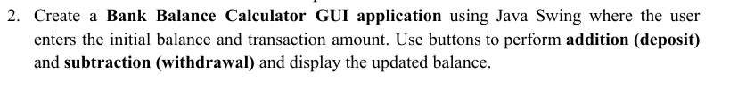
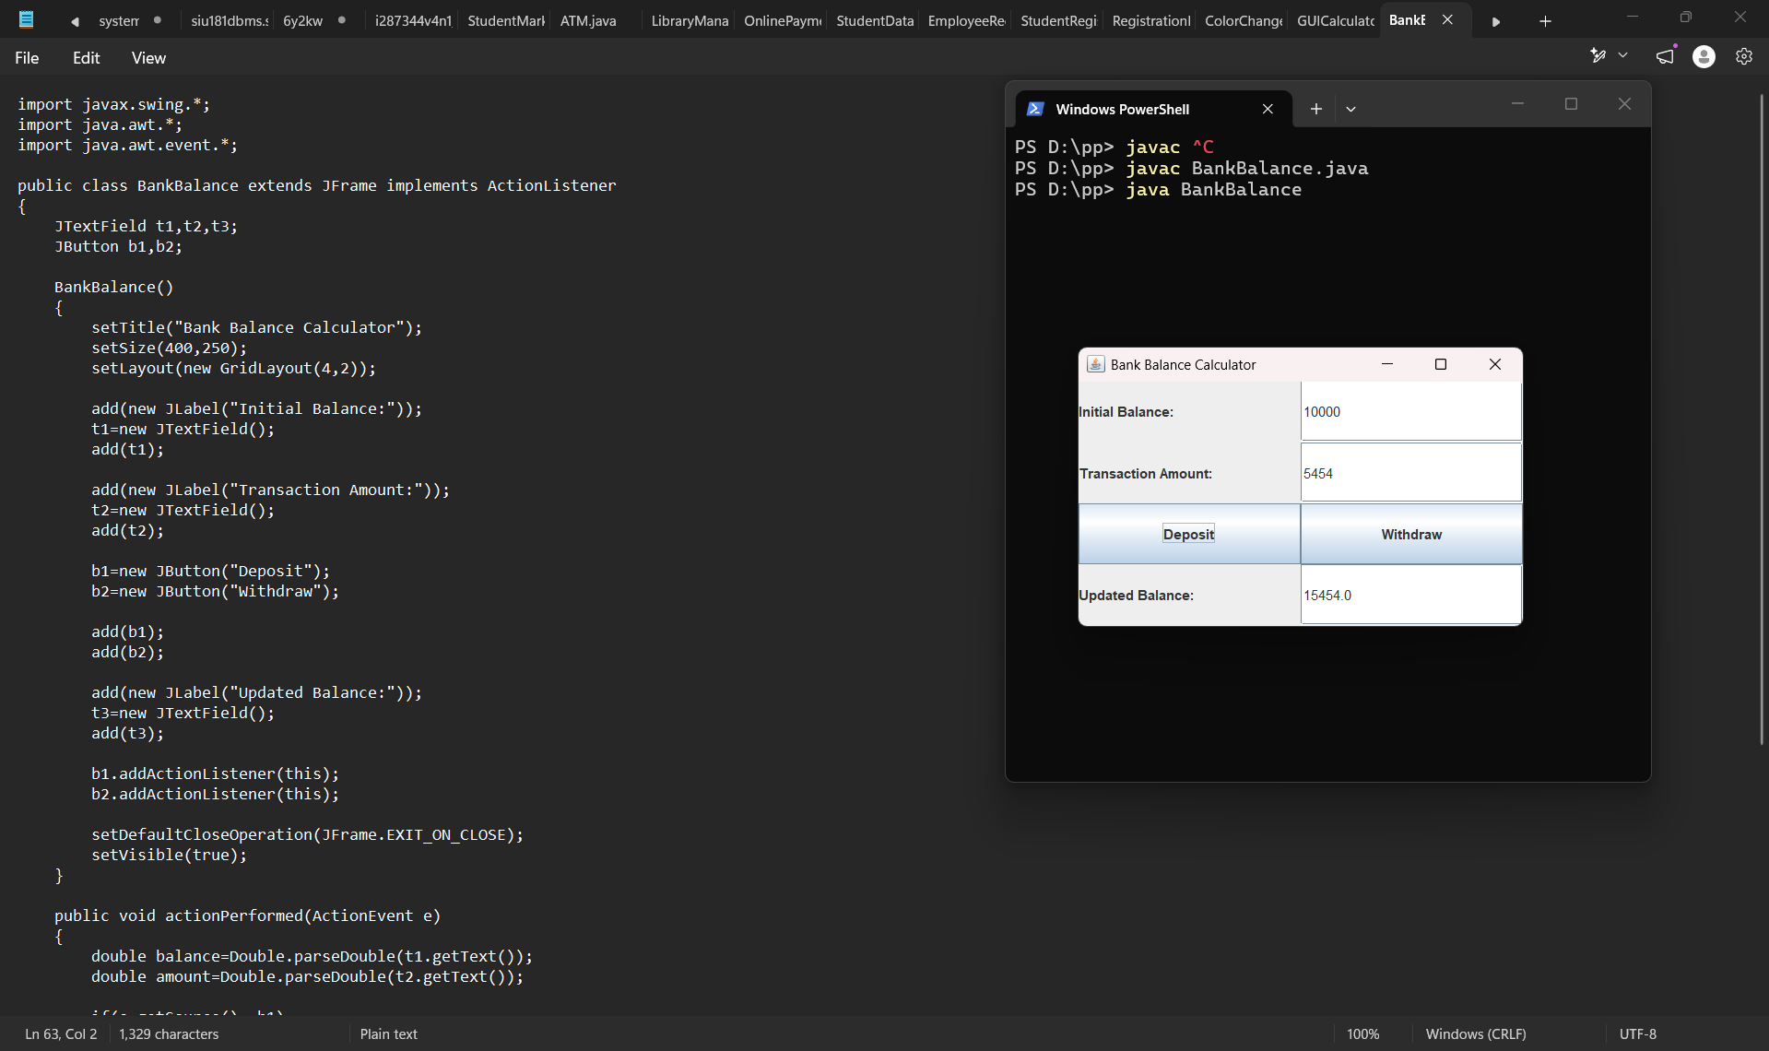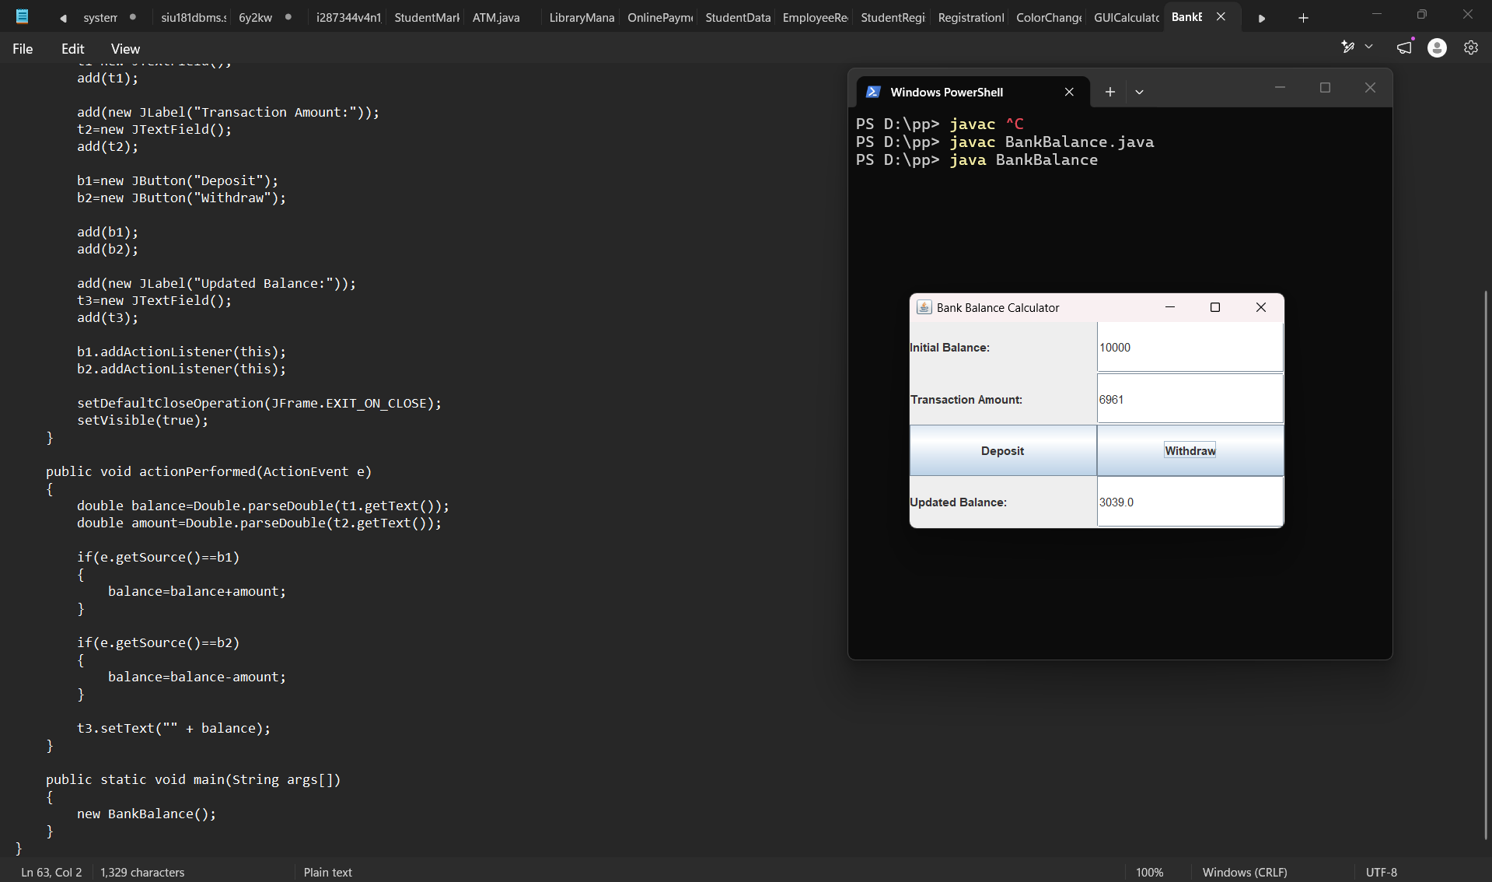

3. Conclusion
Thus, we learned how to implement button-click event handling in Java using Swing components and the ActionListener interface. The program accepts user input, performs the required operation when a button is clicked, and displays the result. Hence, we understood how event handling makes GUI applications interactive.

